## Visvesvaraya Technological University Belagavi-590 018, Karnataka



A Mini Project Report on

## “CLINICAL MANANGEMENT DATABASE”

#### Mini Project Report submitted in partial fulfilment of the requirement for the

**DBMS Laboratory with Mini Project [18CSL58]**

## Bachelor of Engineering

**in**

**Computer Science and Engineering**

### Submitted by

**Prarthana T [1JT19CS063]**

**Rakshith J [1JT19CS069]**



## Department of Computer Science and Engineering Jyothy Institute of Technology Tataguni, Bengaluru-560082

**Jyothy Institute of Technology**

**Tataguni, Bengaluru-560082 Department of Computer Science and Engineering**



## CERTIFICATE

Certified that the mini project work entitled **“CLINICAL MANAGEMENT DATABASE”** carried out by **Prarthana T [1JT19CS063] and Rakshith J [1JT19CS069]** bona-fide students of Jyothy Institute of Technology, in partial fulfilment for the award of **Bachelor of Engineering** in **Computer Science and Engineering** department of the **Visvesvaraya Technological University, Belagavi** during the year **2021-2022**. It is certified that all corrections/suggestions indicated for Internal Assessment have been incorporated in the Report deposited in the departmental library. The project report has been approved as it satisfies the academic requirements in respect of Project work prescribed for the said Degree.

##### Mrs.Nikitha S Dr. Prabhanjan S

Guide, Asst. Professor Professor & HOD

Dept. of CSE Dept. of CSE

External Viva Examiner Signature with Date : 1.

2.

## ACKNOWLEDGEMENT

Firstly, we are very grateful to this esteemed institution **“Jyothy Institute of Technology**” for providing us an opportunity to complete our project.

We express our sincere thanks to our **Principal Dr. Gopalakrishna K** for providing us with adequate facilities to undertake this project.

We would like to thank **Dr. Prabhanjan S, Professor and Head of Computer Science** and Engineering Department for providing for his valuable support.

We would like to thank our guides **Mrs.Nikitha S, Assistant Professor** for their keen interest and guidance in preparing this work.

Finally, we would thank all our friends who have helped us directly or indirectly in this project.

**Prarthana T[1JT19CS063]**

**Rakshith J[1JT19CS069]**

## ABSTRACT

The application is designed to make the existing system more reliable, fast and easy for all, provides a methodical way of managing large databases. For this application we used the backend as SQL to store the data which is used in the application and for the user interface, we have used JAVA.

We have designed a database system named, Clinical Database Management System to maintain the entire details of clinic

The insertion of Doctor details, Patient records, Set appointments, Generate bill. This authority is given only to Staff.

Any modification to be done in the doctor name or patient record can be done by Staff. Right to remove any doctor details rests with Staff too.

**TABLE OF CONTENTS**

|  |  |  |
| --- | --- | --- |
| **SL No** | **Description** | **Page No.** |
| 1 | INTRODUCTION | 6-8 |
| 2 | DESIGN | 9-12 |
| 3 | IMPLEMENTATION | 13-18 |
| 4 | RESULTS AND SNAPSHOTS | 19-27 |
| 5 | CONCLUSION | 28-30 |

# CHAPTER 1 INTRODUCTION

 **INTRODUCTION**

#### Introduction to DBMS

A database is simply an organized collection of related data, typically stored on disk, and accessible by many concurrent users, it is a logically coherent collection of data with some inherent meaning, representing some aspect of real world and which is designed, built and populated with data for a specific purpose.

Databases are managed by a Database Management System(DBMS) which is a collection of programs that enables user to create and maintain a database.

Advantages of DBMS: Redundancy is controlled.

Unauthorized access is restricted. Providing multiple user interfaces. Enforcing integrity constraints.

Providing backup and recovery.

#### Introduction to SQL

Structured Query Language (SQL), is a language used to request data from a database which includes database creation, deletion, retrieval of required tables and even manipulation of data held in a relational database management system.

SQL is considered as a Non-Procedural or a High level language in which the expected result or operation is given without the specific details about how to accomplish the task. So, SQL is a declarative language.

Therefore, SQL is designed at a higher conceptual level of operation than procedural languages as procedural languages includes only the information about opening and closing tables, loading and searching indexes, or flushing buffers and writing data to file systems, but the lower level logical and physical operations are not specified in SQL.

##### Introduction to Clinical Database

Clinical database is a healthcare analytics platform to improve overall performance.

It’s a staple resource for most health and medical data.

Clinical database consists of observational data collected on patients to meet specific criteria.

It manages basic information regarding patient details such as medical records, appointments, doctor records, and also helps staff to generate the bill amount

##### Scope and importance of work

The scope of the project is to give a simple application to overcome the drawbacks of the normal file processing system.

In our application, the database stores details about patients, doctors, staff and billing.

In the Clinic, Staff help patients to get the appointments according to their needs by fetching their personal details which is name, phone number, age, gender, date.

After the appointment stage the patient must submit his/her medical records which consists of details such as Diagnosis, Symptoms, Medication etc.

Specified Doctor will go through the records during or before the consultation period provided to the patient.

Each doctor will be recognized by Doctor ID, Doctor Name, Gender, Email ID.

After the consultation period the patient will awarded with the bill which is generated according to the time span of the consultation period.

# CHAPTER 2 DESIGN

### Theory of ER Diagram

The Entity–Relationship model (ER model) describes the structure of a database with the help of a diagram, which is known as **Entity Relationship Diagram (ER Diagram)**

An **Entity Relationship Diagram (ERD)** shows the relationships of entity sets stored in a database. An entity in this context is an object, a component of data.

An entity set is a collection of similar entities. These entities can have attributes that define its properties. By defining the entities, their attributes, and showing the relationships between them, an ER diagram illustrates the logical structure of database.

ER diagrams are used to sketch out the design of a database.

### ENTITIES

An entity is an 'object' in the real world with an independent existence and an entity type defines a collection (or set) of entities that have the same attributes. Each entity type in the database is described by its name and attributes.

An entity type is represented in ER diagrams as a rectangular box enclosing the entity type name.

### RELATIONSHIPS

A relationship among two or more entities represents an association among the entities and whenever an attribute of one entity refers to another entity, there exists a relationship between the two entities.

In a relationship, a foreign key of one table refers the primary key of the other table and it is represented by diamond shape in ER diagram.

### ATTRIBUTES

An attribute represents some property of interest that further describes an entity and the column header of the table shows the attributes. Each attribute in a table has a certain domain which allows it to accept a certain ‘set of values’ only.

The attribute values, of each entity, will define its characteristics in the table and is represented by oval in the ER diagram.

### ER DIAGRAM

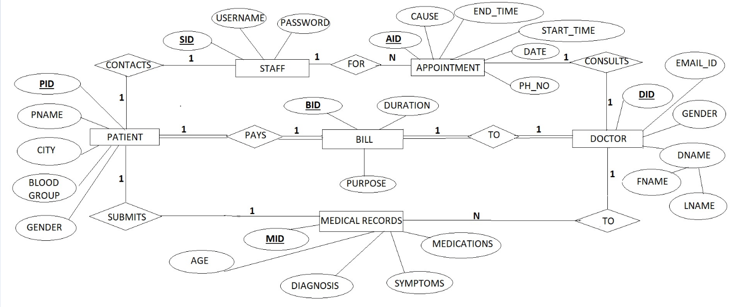

**SCHEMA DIAGRAM**

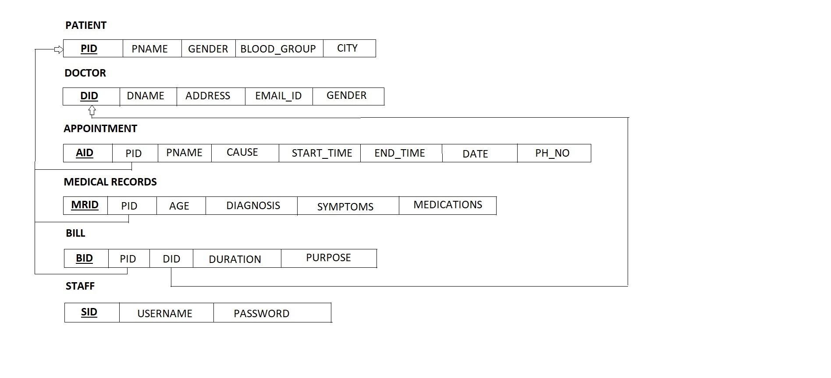

### List of Tables

* + 1. STAFF
    2. APPOINTMENTS
    3. DOCTOR
    4. PATIENT
    5. MEDICAL RECORDS
    6. BILLS

# CHAPTER 3 IMPLEMENTATION

#### Table creation:-

1. create table staff(SID integer primary key auto_increment,UserName varchar(20) not null, Password varchar(20) not null
2. create table patient(PID integer primary key auto_increment,Pname varchar(20) not null,Gender varchar(10) not null,BloodGroup varchar(10) not null,PhoneNumber varchar(20) not null,City varchar(20) not null);
3. create table medRec(PID integer, foreign key(PID) references patient(PID) on delete cascade,MRID integer,Age integer not null,Symptoms varchar(20) not null,Diagnosis varchar(20)not null,Medication varchar(20) not null,primary key(PID,MRID));
4. create table appointments(PID integer not null,foreign key(PID) references patient(PID) on delete cascade,AID integer,Pname varchar(20) not null,Cause varchar(20) not null, StartTime time not null,EndTime time not null,Date date,PhoneNumber varchar(20) not null,primary key(PID,AID));
5. create table doctor(DID integer primary key auto_increment,FirstName varchar(20) not null,LastName varchar(20) not null,Gender varchar(10) not null,EmailID varchar(30) not null,Address varchar(20) not null);
6. create table bills(BID integer primary key,PID integer,foreign key(PID) references patient(PID),DID integer,foreign key(DID) references doctor(DID),Duration integer not null,Purpose varchar(20),Amt integer);
7. create trigger insertAmt before insert on bills for each row set new.Amt=(new.Duration*10);
8. create trigger updateAmt before update on bills for each row set new.Amt=(new.Duration*10);

#### Table Descriptions

#### 

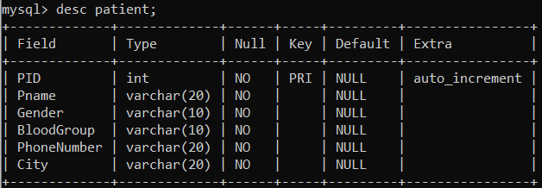

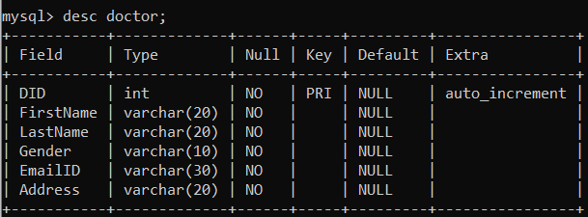

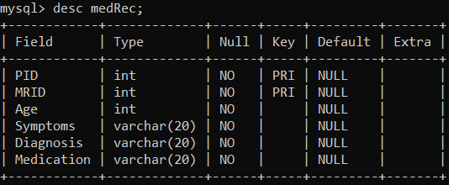

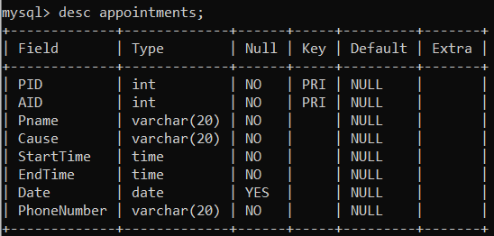

#### 

**NetBeans Implementation**

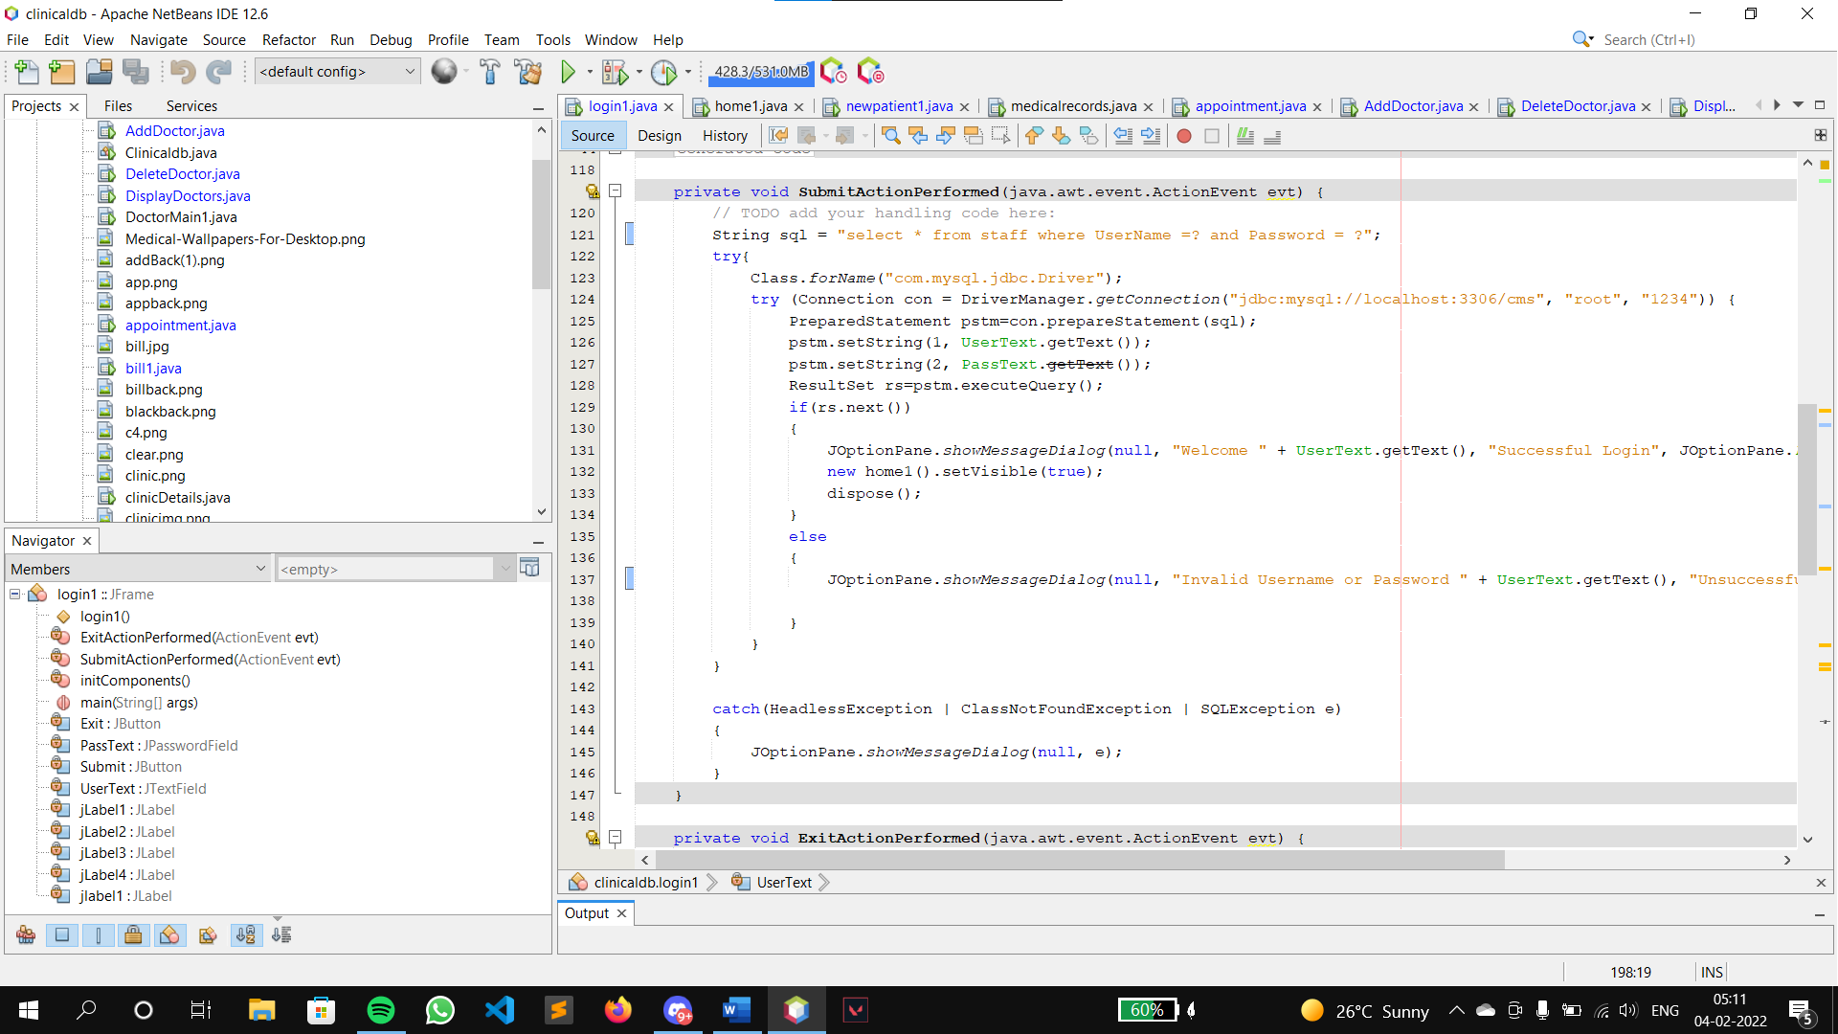

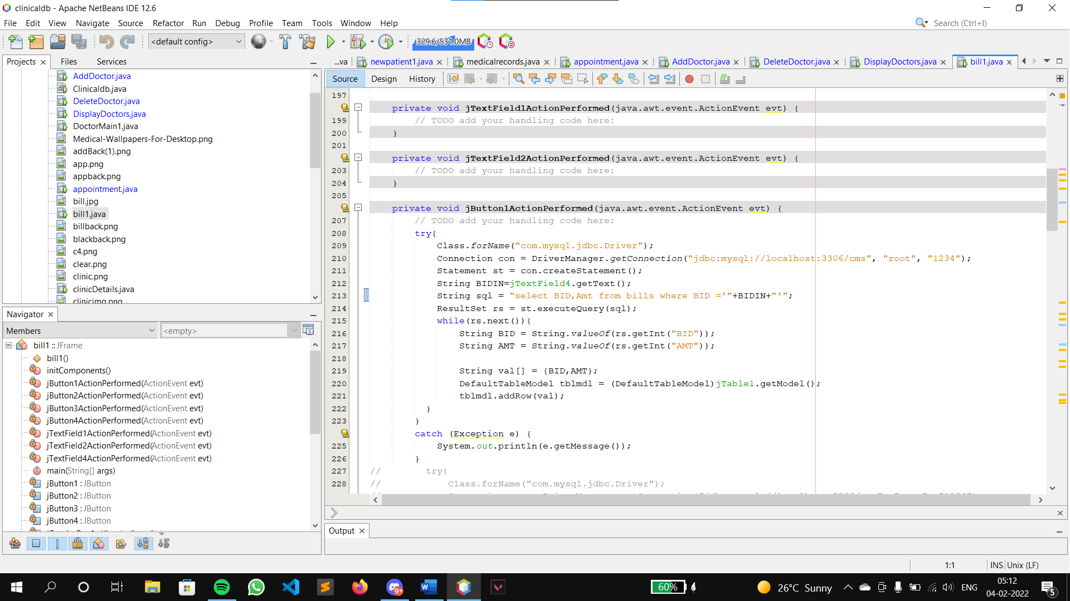

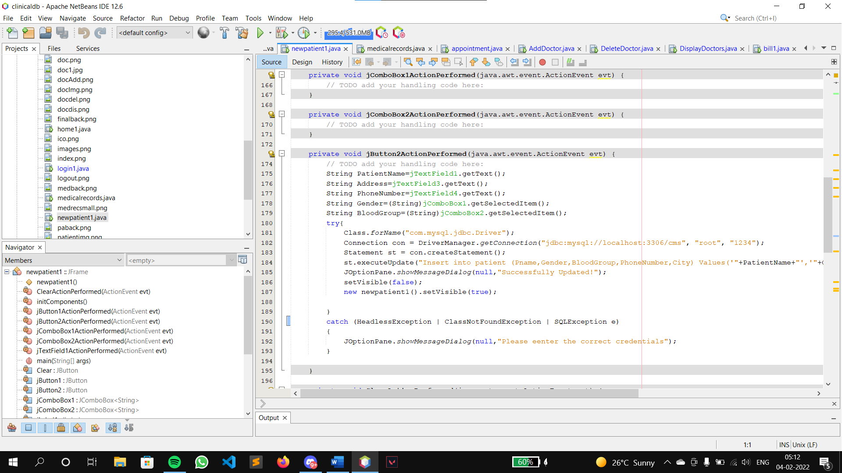

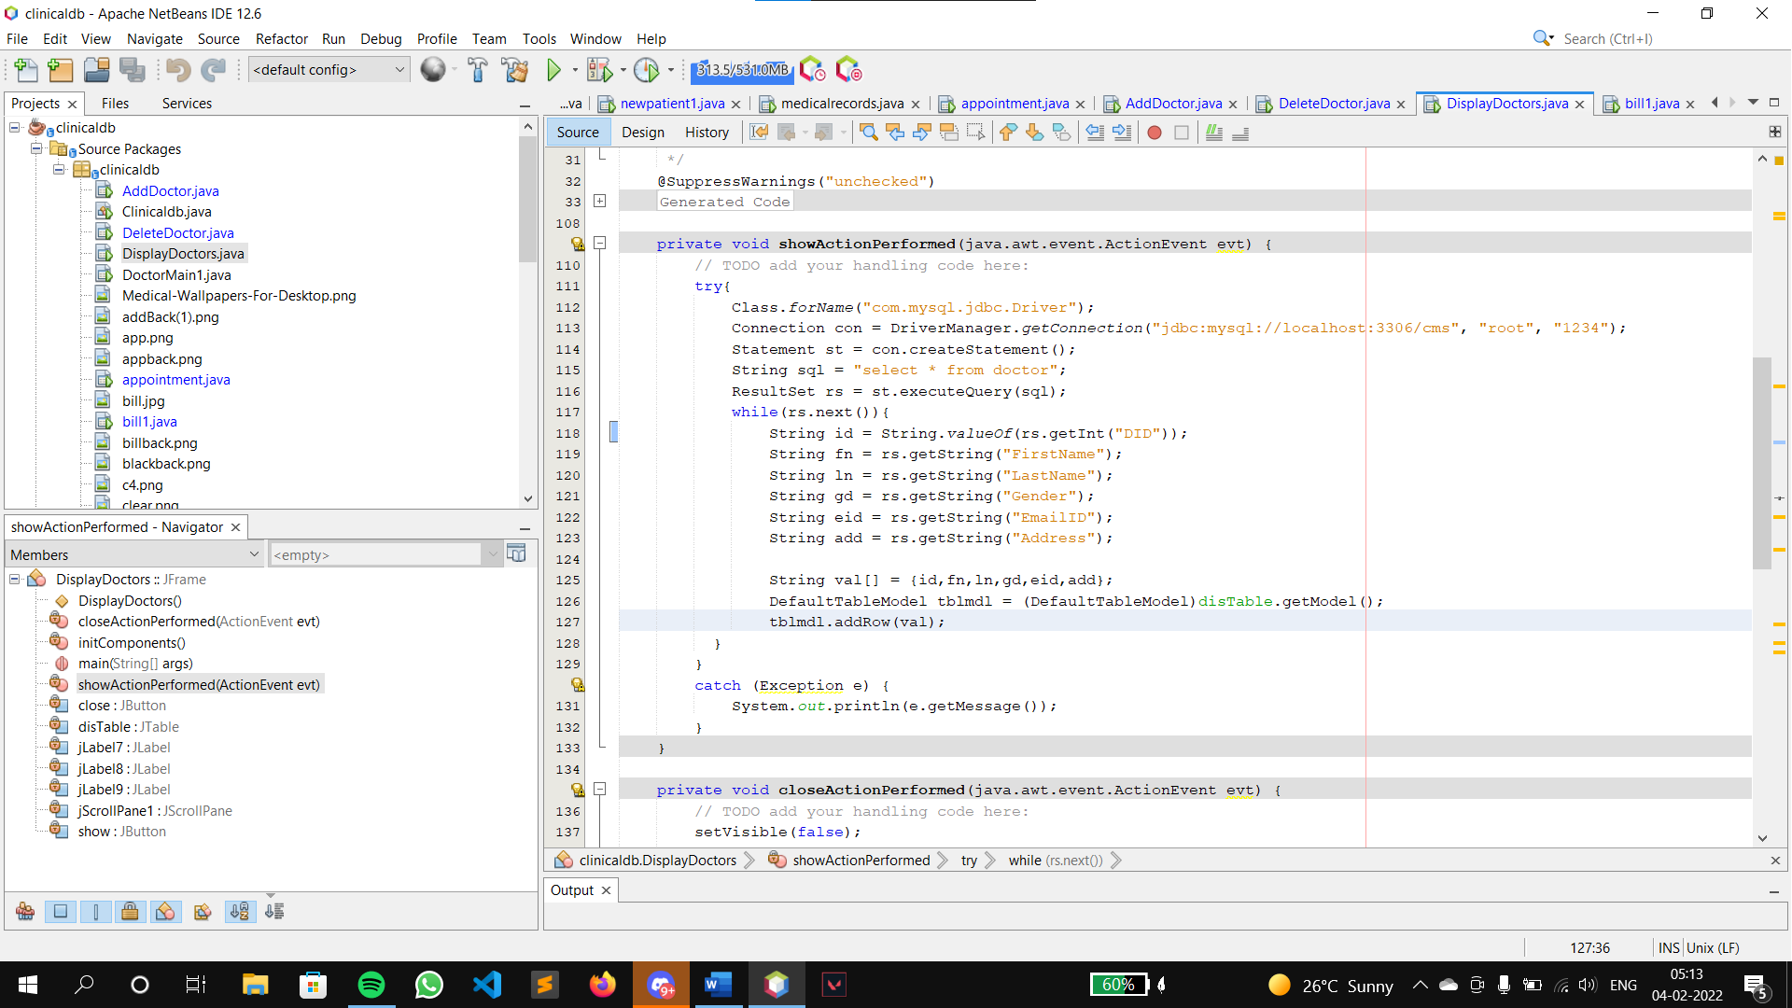

# CHAPTER 4 RESULTS AND SNAPSHOTS

### LOGIN PAGE

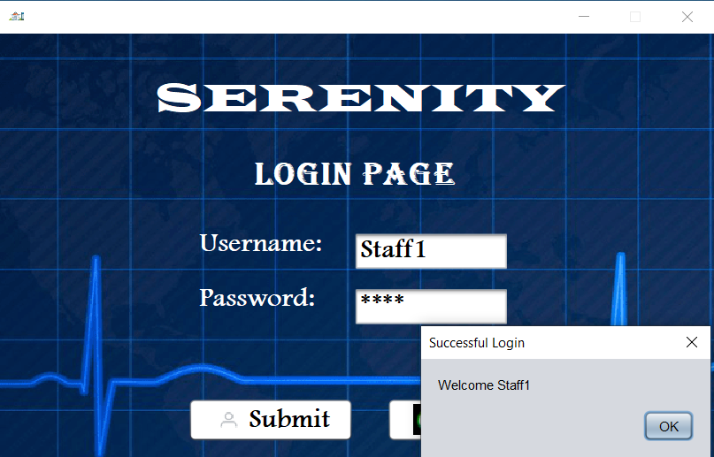

#### HOME PAGE

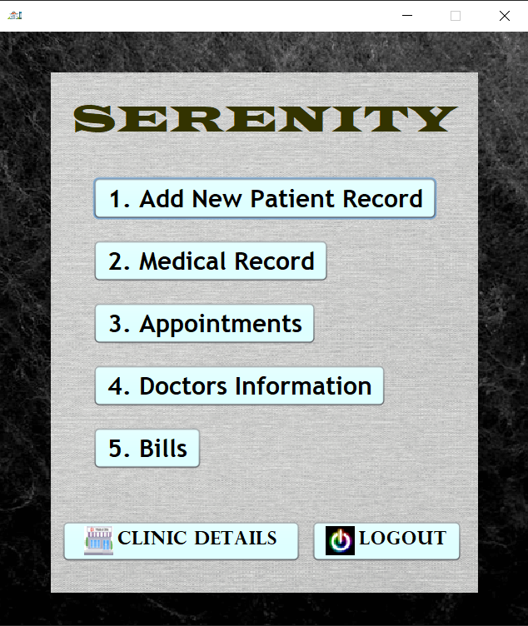

**ADD NEW PATIENT**

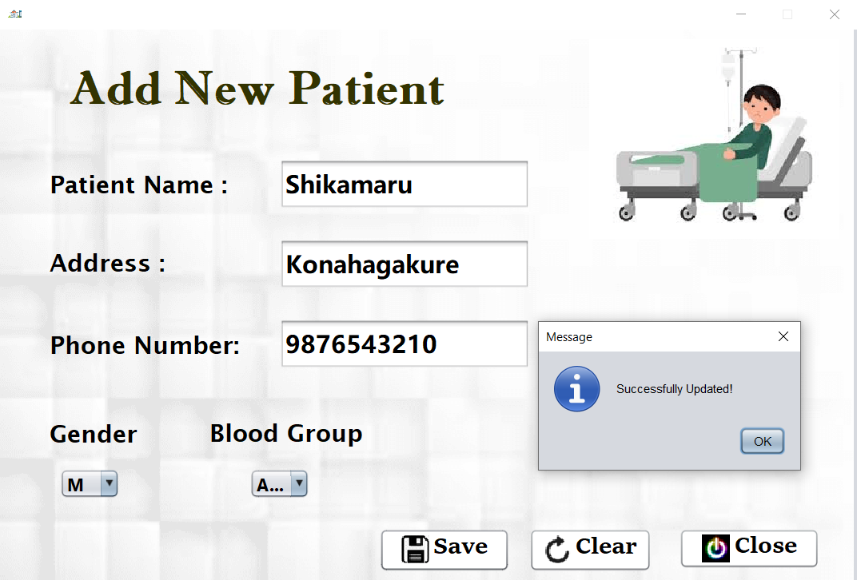

#### MEDICAL RECORD

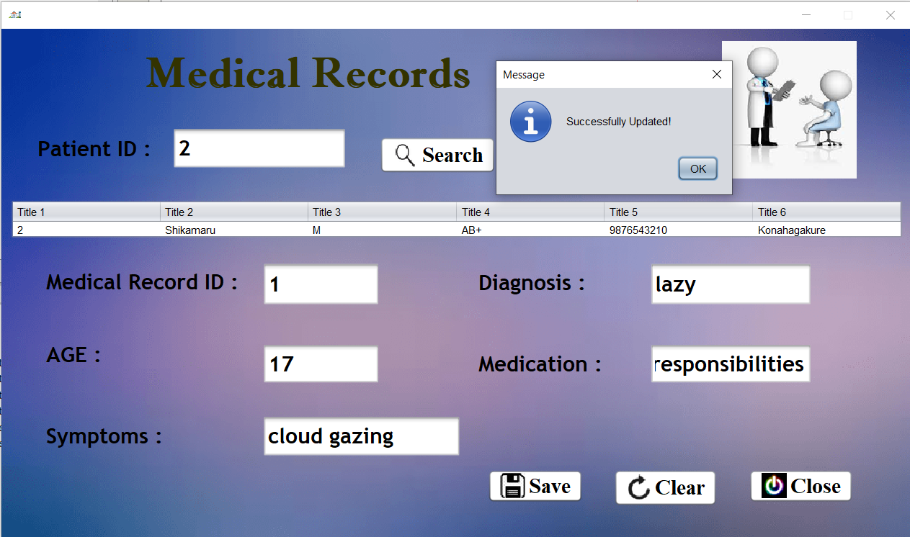

**SET APPOINTMENTS**

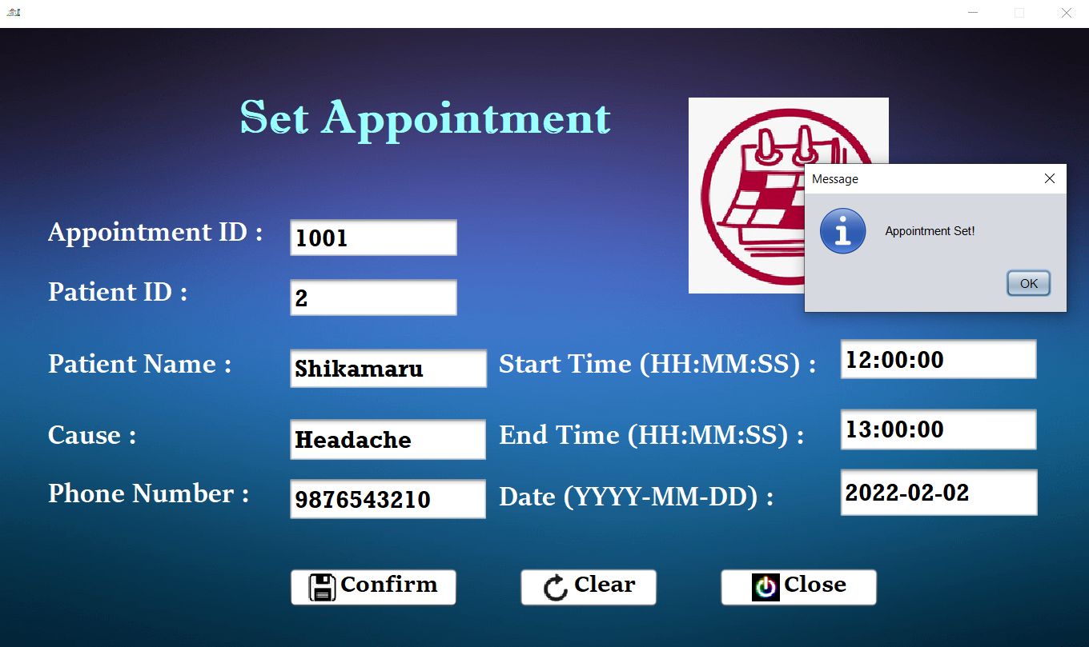

#### DOCTOR MENU

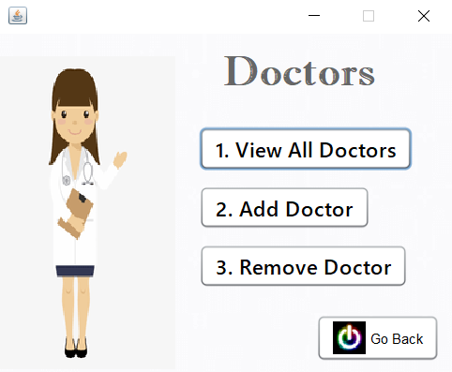

**ADD DOCTOR**

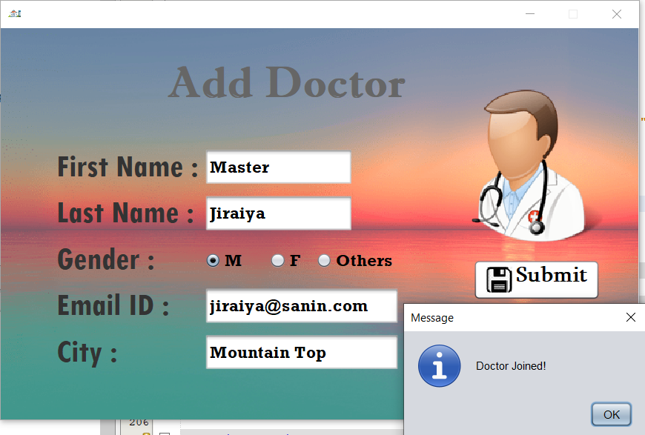

#### VIEW DOCTORS

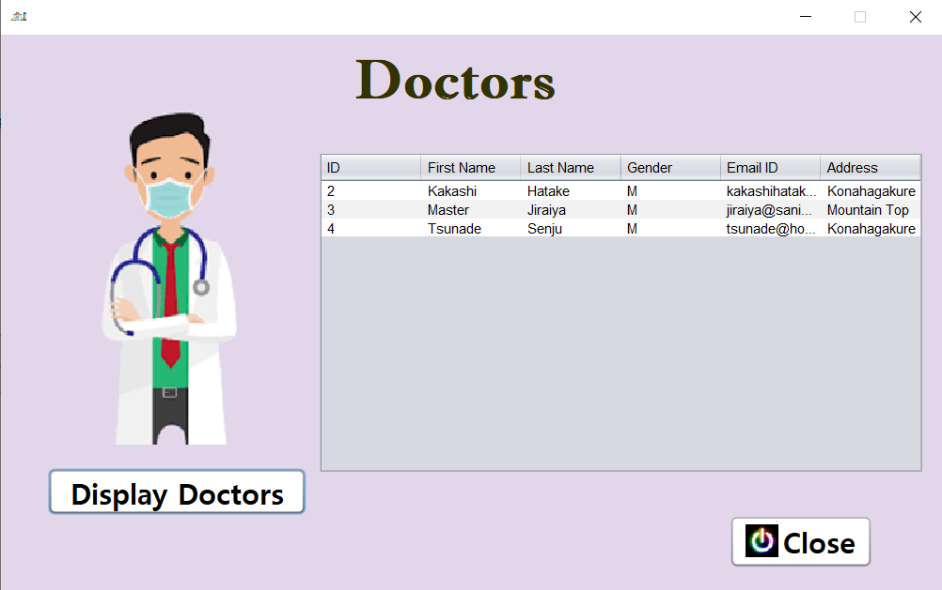

**DELETE DOCTOR RECORD**

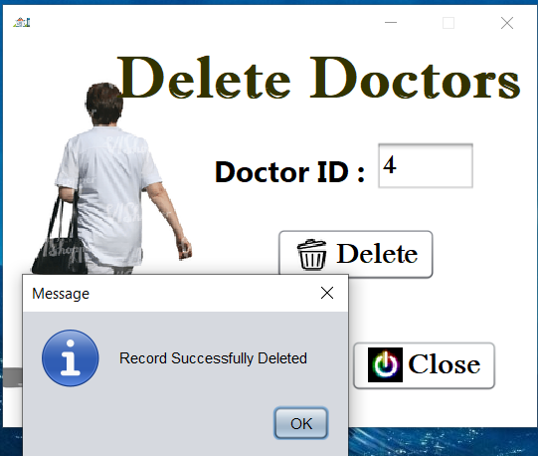

**BILLS**

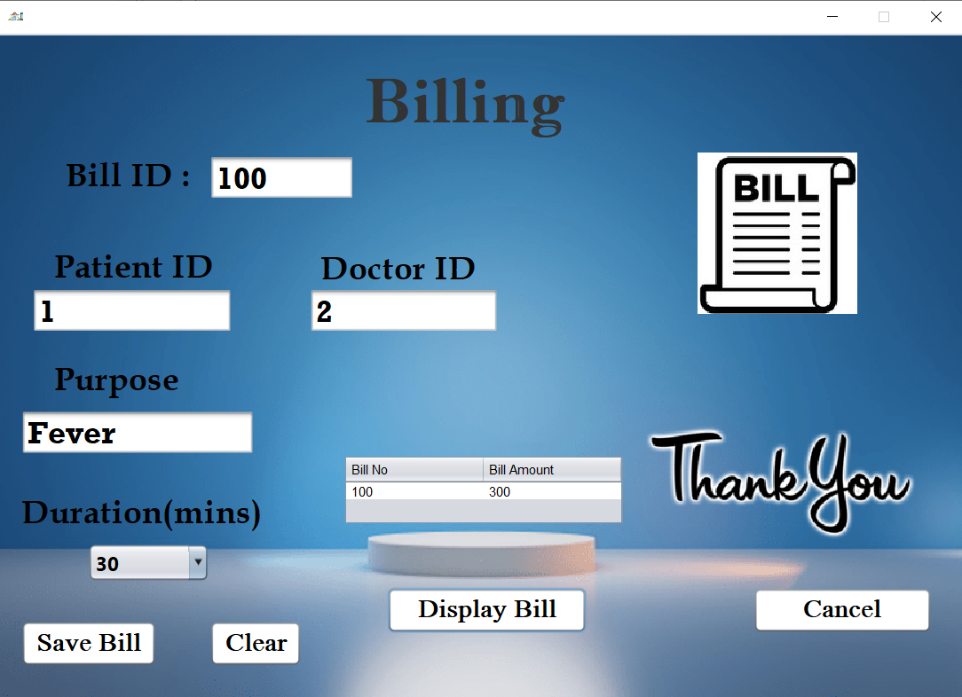

### CLINIC DETAILS

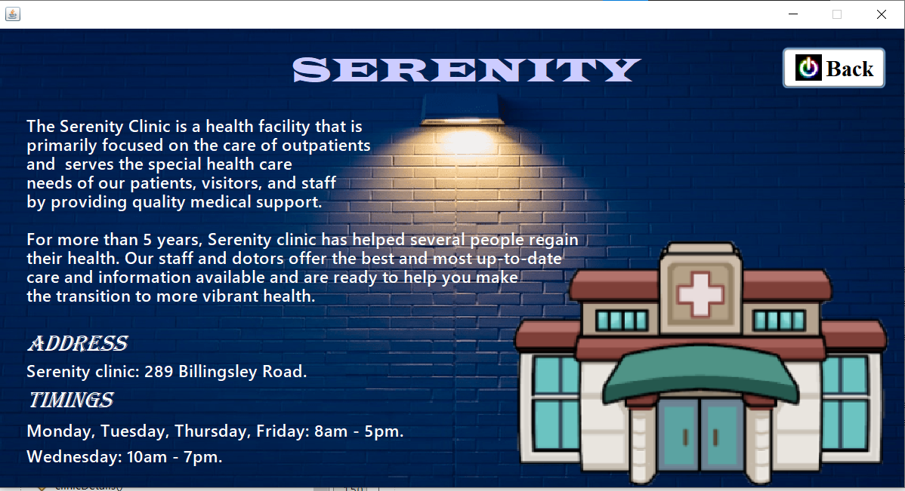

**QUERIES**

* + - * 1. Delete from the table doctor where the DID = 2

➔ delete from doctor where DID =2;

* + - * 1. Display patients who’s age is under 18

➔ select PID,age from medRec where age<18;

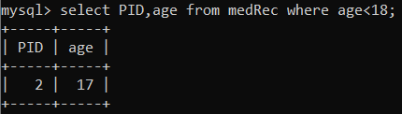

* + - * 1. Show the resulting bill if bill amount increased to 20% if given the consultation period exceeds 15 mins

➔ create view NewBill1 as select BID,PID,Amt*1.2 as New_Amt from bills where Duration > 15;

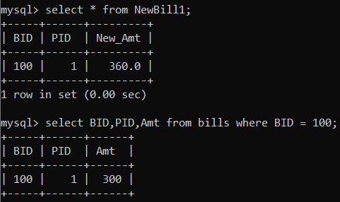

* + - * 1. Find the Patient ID , Pname ,Appointment ID , Bloodgroup where 1 or more patients have placed 1 or more appointments.

➔ select A.PID,A.Pname,A.AID,P.BloodGroup from appointments A,patient P where P.PID =A.PID and A.PID in(select A.PID from appointments A group by PID having count(*)>1) ;

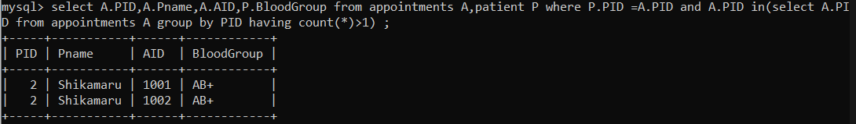

* + - * 1. List all the doctors who attended the patients between 31s of January 2022 and 3rd of February 2022

➔ select D.DID,A.Date,D.FirstName,D.LastName from doctor D join bills B on B.DID = D.DID join appointments A on A.

PID= B.PID where A.Date between '2022-01-31' and '2022-02-03';

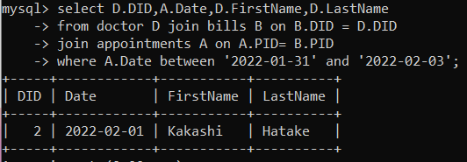

# CHAPTER 5

# CONCLUSION

### Conclusion

We have successfully implemented the CLINICAL DATABASE which helps in managing the data used to perform the various tasks in the clinic.

View tables are used to display all the components of different entities that user needs. One can just select the buttons and modify the data as per requirements.

We have successfully used various functionalities of JAVA and SQL and created the fully functional database system

Clinical Database has to do with making appropriate effort to stop the rising problem of all manual Clinic operation in order to enhance the operation of such Clinic.

In this project, the software or system that can be used to aid all Clinics that is still struggling with dealing with patient records, appointments, doctor records, billings etc…. has been successfully developed.

The software can be implementing in all types of Clinics

### Features

1. A password system that will be embedded into login page to increase the Security of the system.
2. A good Printing module should be included.
3. A data required for different operations are accessible to the admin.
4. Quick and easy saving and loading of database file.

### References

Net Beans 12.6

https://netbeans.apache.org/download/nb126/

JDBC Driver for MySQL (Connector/J)

<https://dev.mysql.com/downloads/connector/j/5.1.html>

MySQL Database

<https://www.mysql.com/downloads/>